**Games Programming 2**

**Coursework Documentation**

Name: Sean Muldoon

Matriculation number: S1714073

Course: Computer Games (Software Development)

*I confirm that the code contained in this file (other than that provided or authorised) is all my own work and has not been submitted elsewhere in fulfilment of this or any other award*.

*Sean Muldoon*.

Contents

1. Controls 3

**1.** main 4

**2.** Display 5

**3.** Mesh 6

**4.** Texture 8

**5.** Shader 9

**6.** Audio 10

**7.** Ball 11

**8.** Camera.h and transform.h 13

**9.** GameLoop 14

# Controls

The main camera is controlled with the WASD keys to move around the scene and the arrow keys to turn and pitch the camera.

The space key can be pressed to launch the golf ball into the air.

# main

The main class is simply used as an entry point to the program.

It initialises the GameLoop class before calling its Run() method and returning 0.

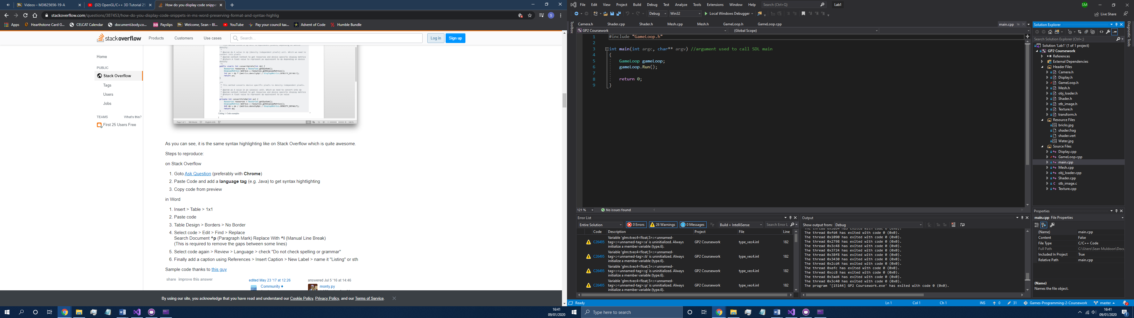

# Display

The display class is responsible for handling the game window.

Firstly the display is set up in the InitDisplay() method by initialising all of the OpenGL required attributes as well as the RGBA sizes and double buffer.

The game window is then created with a specified width and height, if the window is invalid, an error message is printed. The same is done for the OpenGL context.

Finally, z-buffering and the functionality to cull out of view faces is enabled.

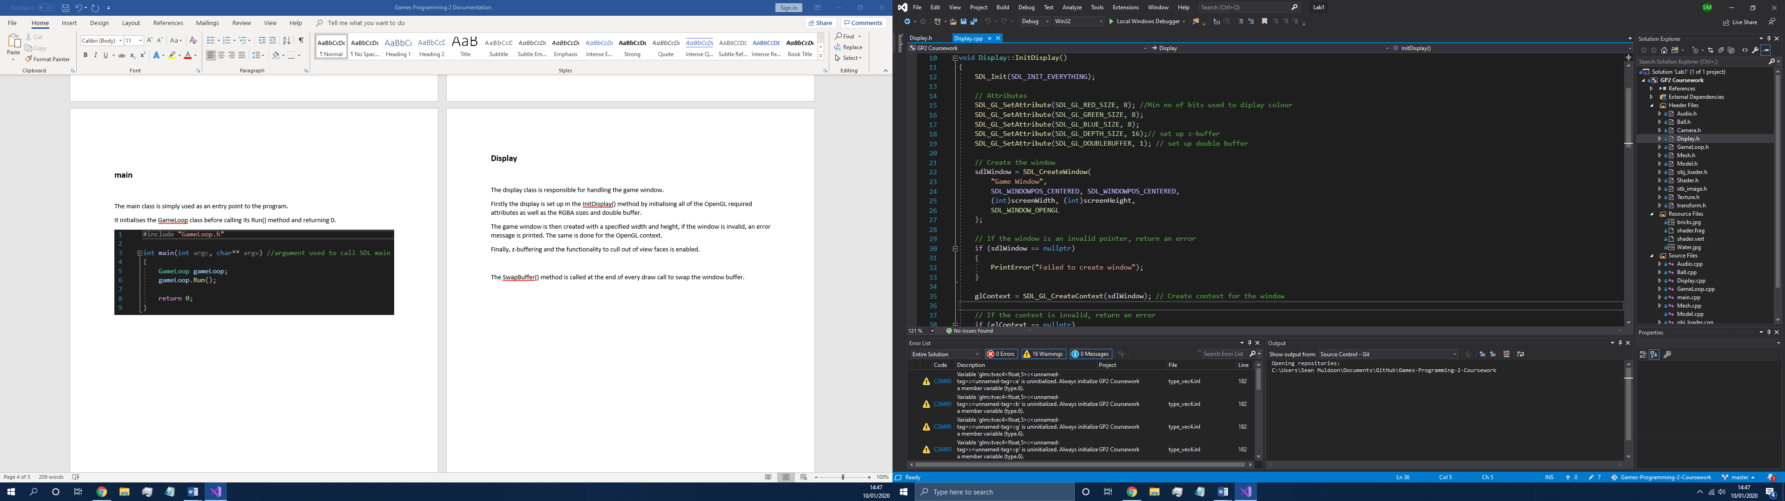

The SwapBuffer() method is called at the end of every draw call to swap the window buffer.

The ClearDisplay(float r, float g, float b, float a) method takes and RGBA value and refreshes the draw with that colour as the background. In this game a light blue-sky colour is used.

The PrintError(char* errorMessage) method is used to handle fatal errors. It takes a string of chars and prints the message to the console before quitting out of SDL after a keystroke.

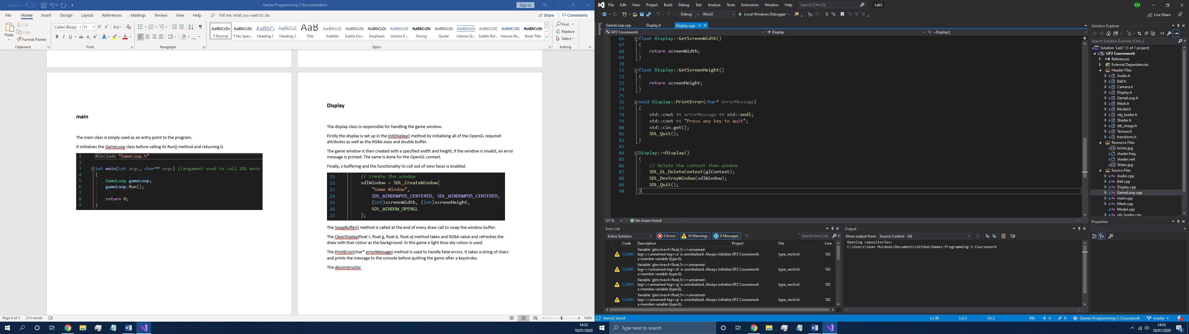

The deconstructor cleans up the window creation by deleting the context, destroying the window and quitting SDL.

# Mesh

The mesh class primarily handles the loading and storing of the games meshes. It also contains the methods for drawing the mesh and collision bounding.

The LoadModel(const std::string& filename) method takes in a string for the models filename. The filename is then appended to “..\\res\\” to locate the model from the games resource folder. Relative addressing is used to ensure the model can be found regardless of the games location on the computer.

This model is then loaded into a useable mesh using the OBJModel library.

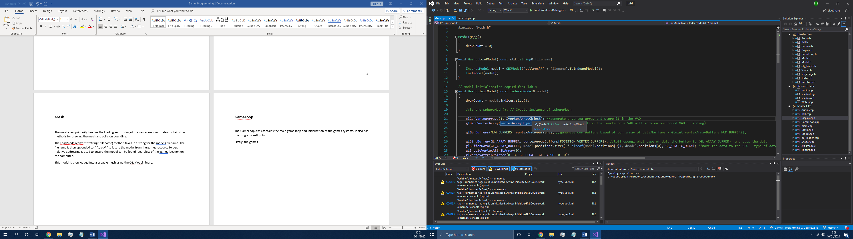

The model is then initialised in the InitModel() method. This is done by firstly generating a VAO and binding it. The next step is to generate the required buffers and bind them, these are the vertex positions, texture coordinates, normal vectors and indexes.

Finally the VAO is unbound.

The Draw(GLuint texture) method is called to draw the mesh on the screen. It takes in a textures address and binds it for use with the VAO.

Next, OpenGLs glDrawElements() method is called to draw the textured mesh to the screen. A check is done to ensure the model has at least some amount of indices. This makes sure there are no visual artifacts when the mesh is drawn. The last step is to then unbind the VAO again.

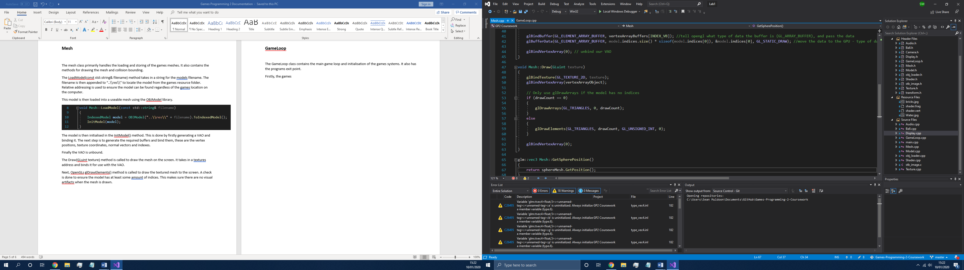

The GetSpherePosition(), GetSphereRadius() and UpdateSphere(glm::vec3, float) methods all handle the getting and setting of the meshes collision bounds. Currently these may only be of a spherical shape which is fine for the moment, but future versions would allow for cubic or cylindrical bounds.

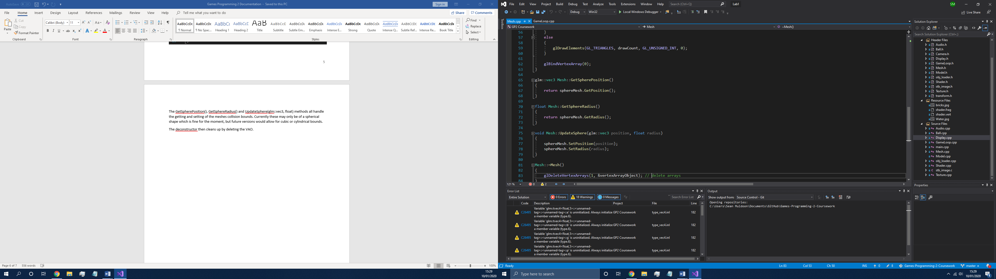

The deconstructor then cleans up by deleting the VAO.

# Texture

The Texture class is responsible for initialising and binding textures to be used in the game. These textures are later applied to the games meshes.

Most of the classes functionality is done in the InitTexture(const std::string& filename) method. The method works by taking in a filename and returning an OpenGL unsigned int that is used to reference the texture when it is required.

The filename is used to locate and load the texture from the games resource folder in a similar way to how models are loaded. The loading is done with the stbi_load texture loader.

If the image data of the texture is invalid, an error message is printed to the console.

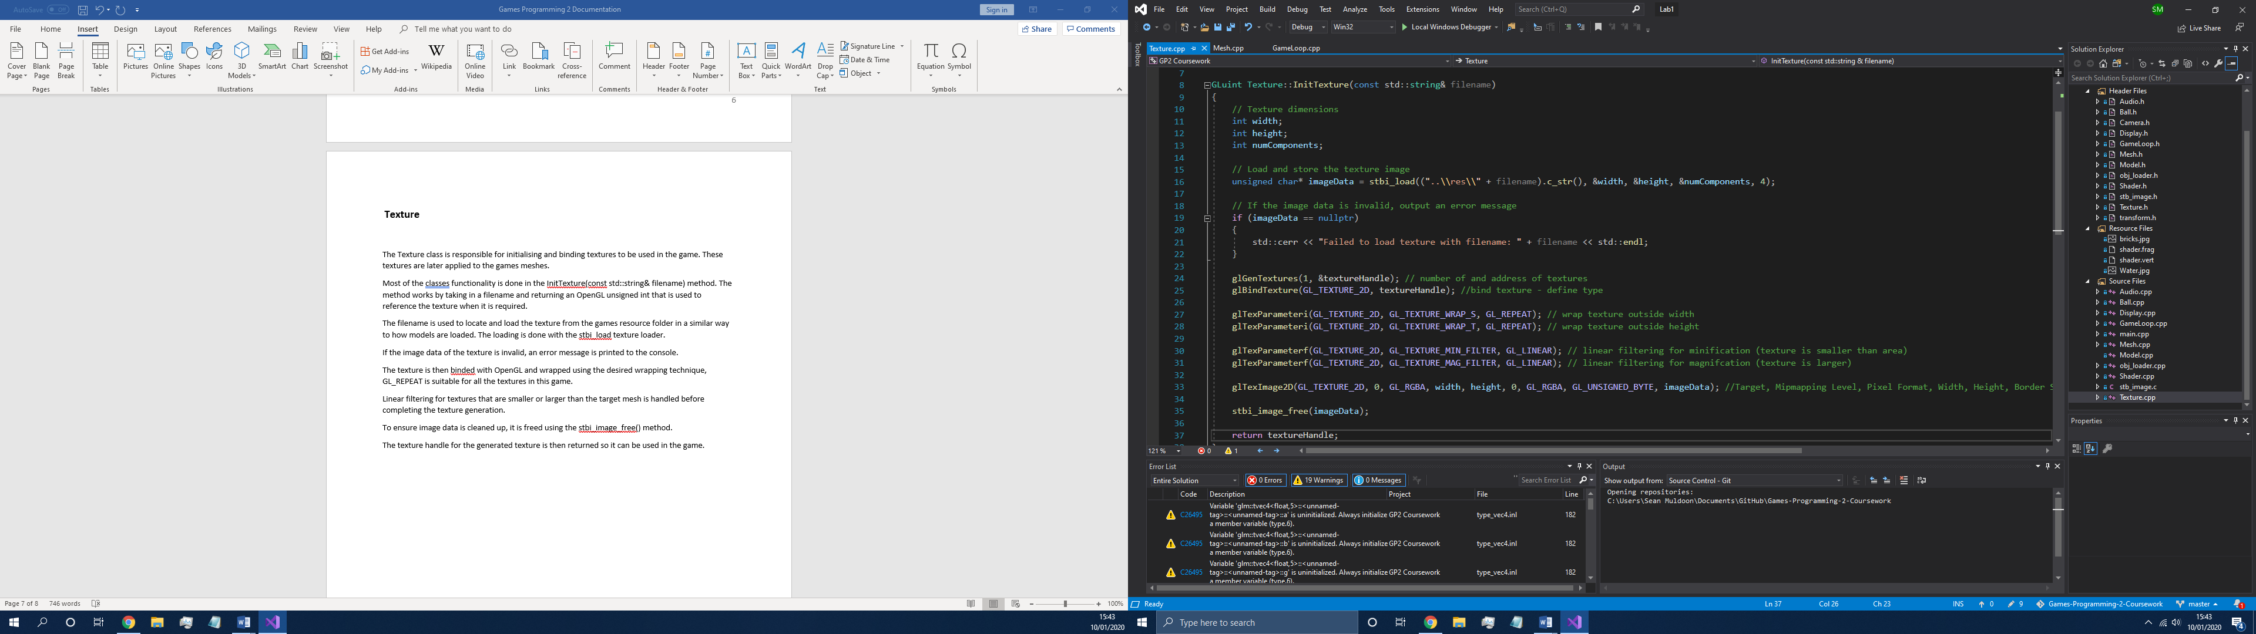

The texture is then binded with OpenGL and wrapped using the desired wrapping technique, GL_REPEAT is suitable for all the textures in this game.

Linear filtering for textures that are smaller or larger than the target mesh is handled before completing the texture generation.

To ensure image data is cleaned up, it is freed using the stbi_image_free() method.

The texture handle for the generated texture is then returned so it can be used in the game.

The Bind(unsigned int uint) method is used to bind the texture. An integer value between 0 and 31 is accepted, else an error message is printed before the binding is done.

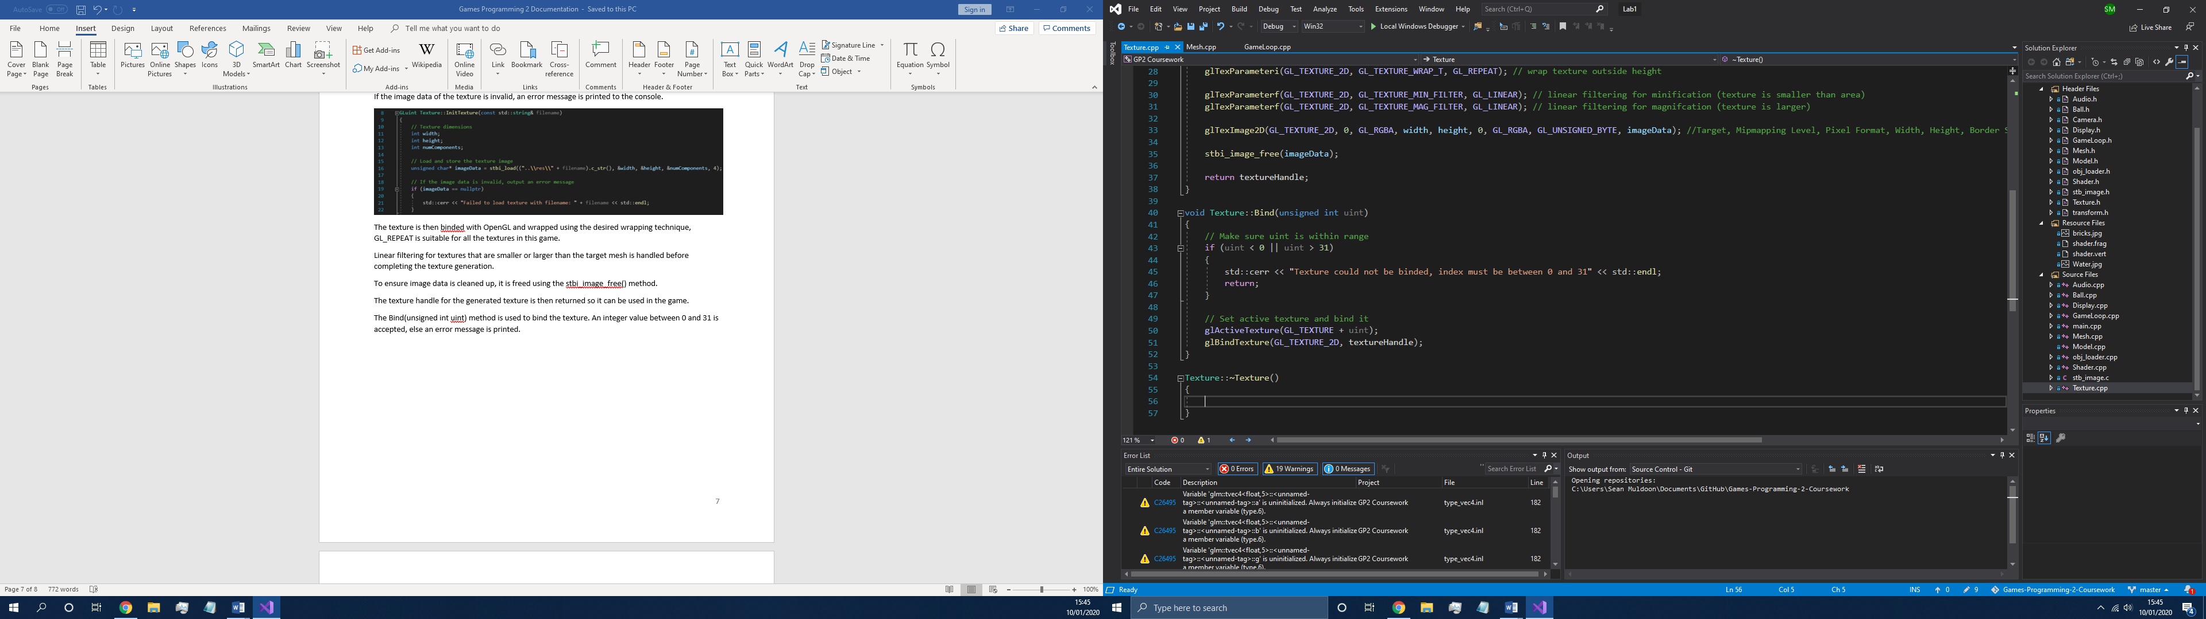

# Shader

The Shader class is used to initialise and create shaders as well as load them for use. It also binds the shader program and has an Update() method to calculate the correct matrices for the current game view.

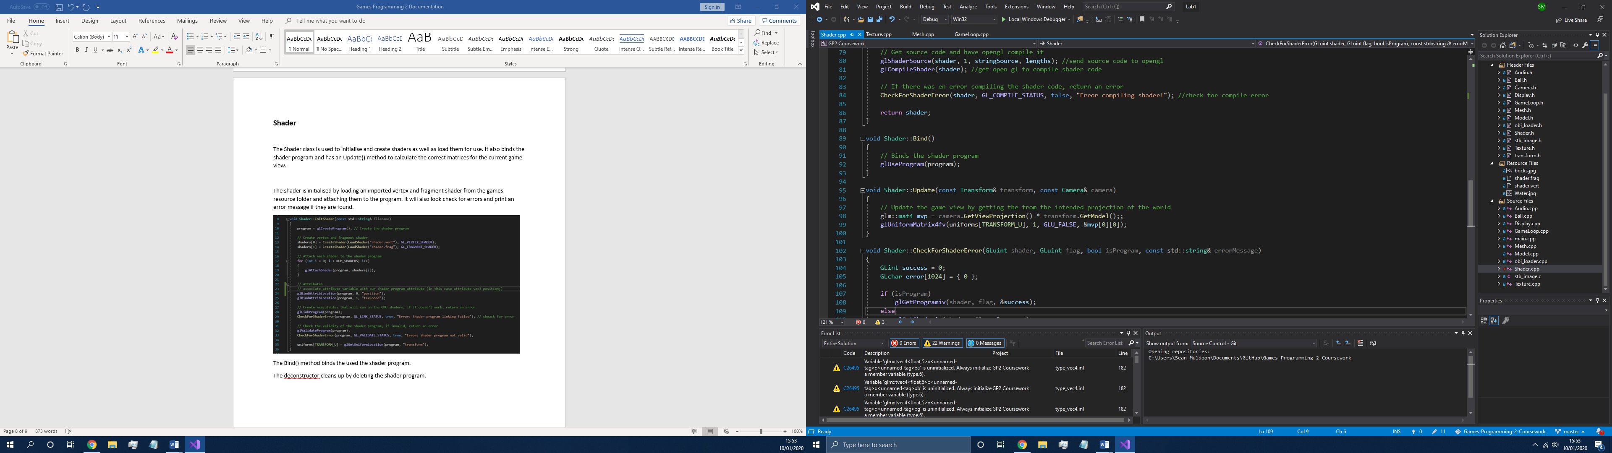

The shader is initialised by loading an imported vertex and fragment shader from the games resource folder and attaching them to the program. It will also look check for errors and print an error message if they are found.

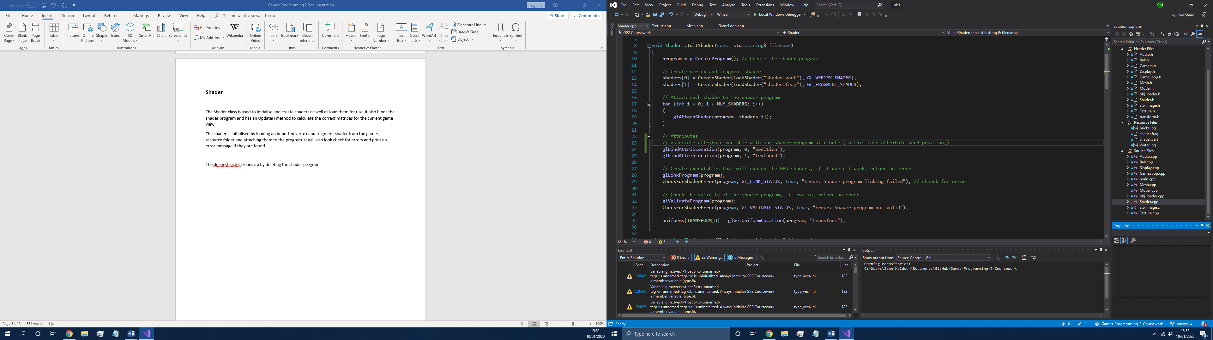

The Bind() method binds the used the shader program.

The deconstructor then cleans up by cycling through each shader and detaching and deleting them and finally deleting the actual shader program.

# Audio

The Audio class handles all of the audio related functionality in the game.

A lot of the methods in this class are either unused or not important to document.

The audio files are loaded with the loadSound(const char* filename) method which loads the desired .wav files from the games resource folder.

The method returns an unsigned integer that is used to reference and therefore use the audio elsewhere in the game.

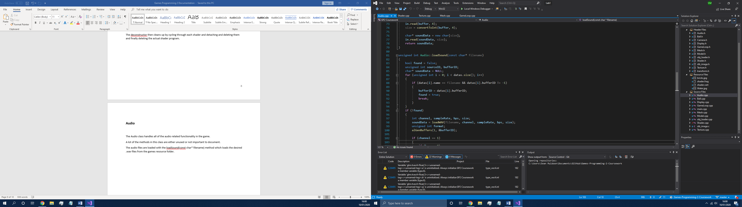

The playSound(unsigned int id) method takes in an unsigned int that points to a sounds address and plays the corresponding audio.

Sounds can also be stopped with the stopSound(unsigned int id) method.

The audio class also cleans up by deleting all the involved sources and buffers.

# Ball

The ball class is used to handle the behaviour of the small golf ball that is located in the game scene.

It has a few methods that control how it moves and collides with other objects.

The ball uses a position and velocity vector to store its physical values as well as a State enum which is simply STOPPED or MOVING, depending on the balls current motion.

The constructor initialises the position and velocity of the ball as well as the current state – which is set to State::MOVING to ensure the ball is affected by physics as soon as the game is started.

When the Launch(float force) method is called, it tries to fire the ball into the air with a specified force. It returns a Boolean value to determine if the launch was successful or not. The ball will only be launched if it is current state is stationary.

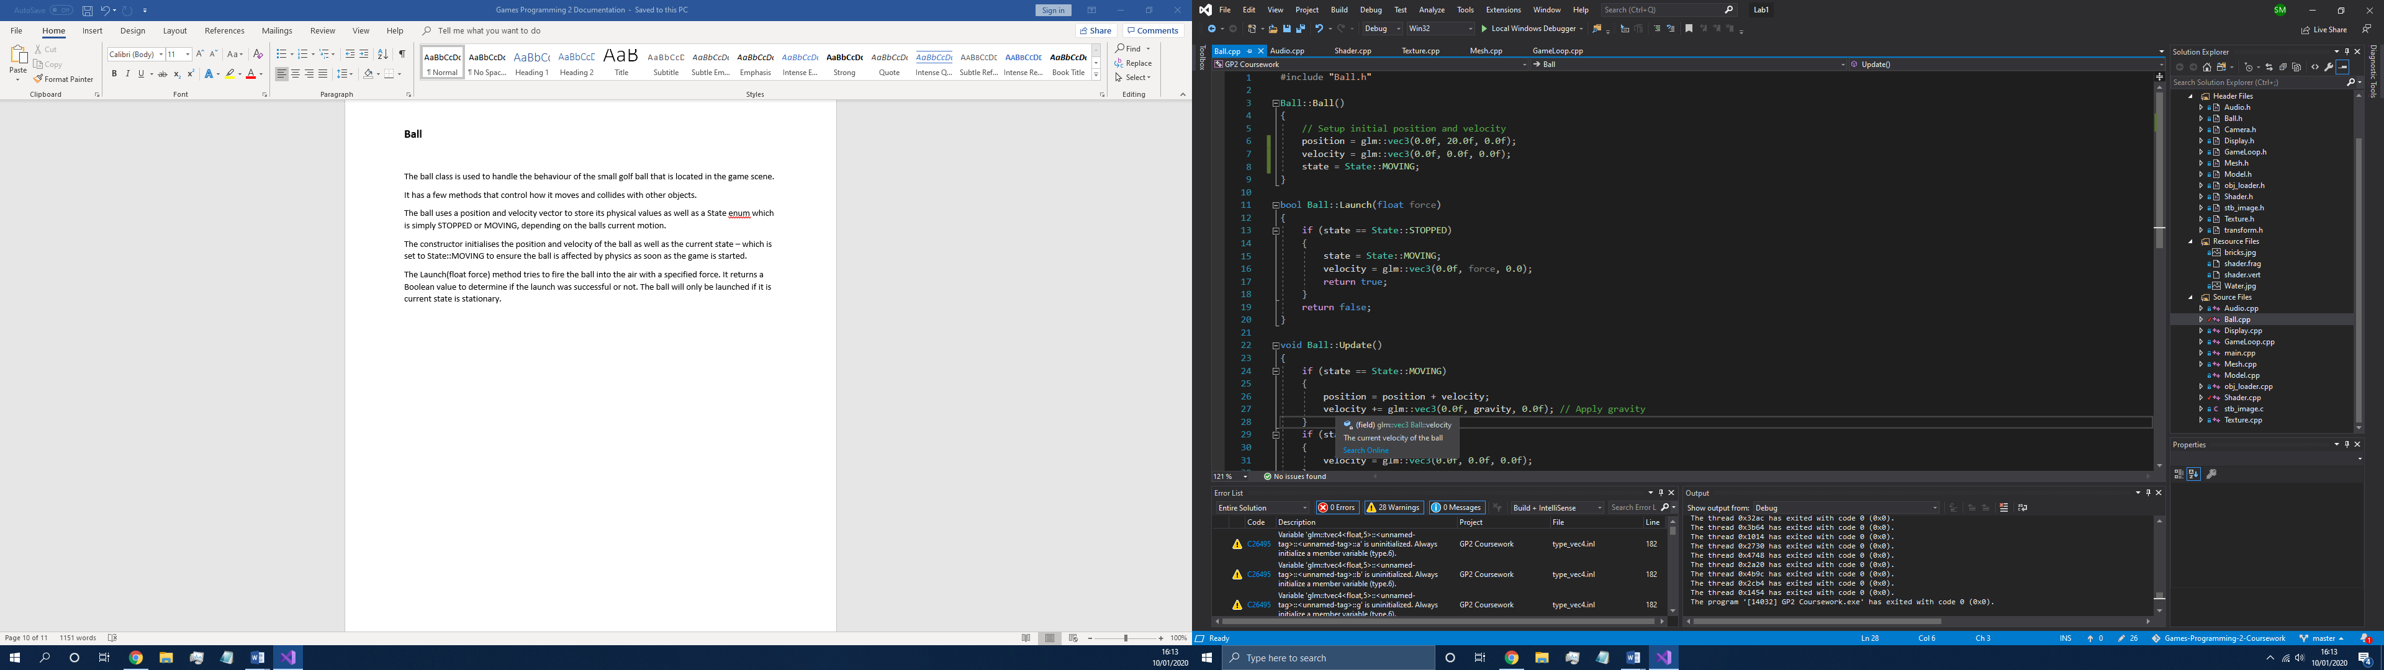

The Update() method is called every game frame and applies physics to the object according to its current state.

If the ball is moving its velocity vector is added to its position vector to simulate momentum. Gravity is then added to the velocity to make sure the ball does not travel upwards forever and gradually falls back down.

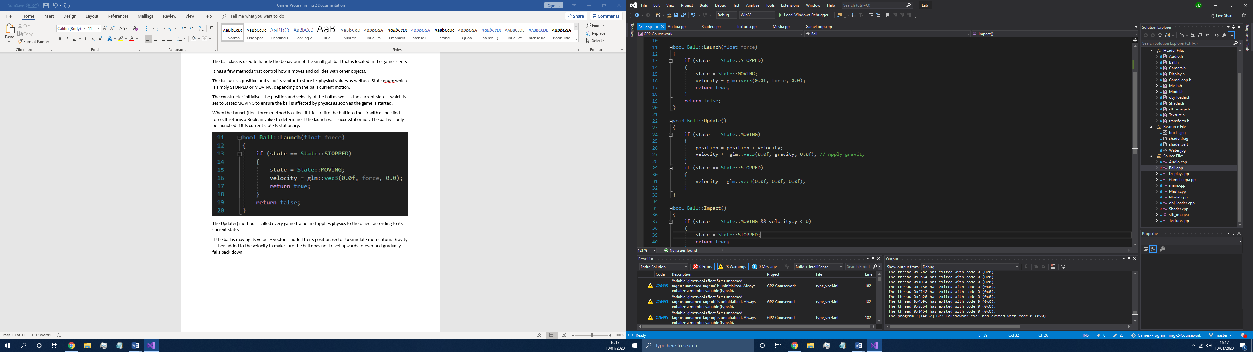

The Impact() method is called whenever the ball collides with another object. It returns a Boolean value that is true if the ball was moving when the collision happened. This is checked to prevent the method being called every frame it is in colliding with something.

If the ball is moving, it is stopped to keep the ball from travelling through the collided object.

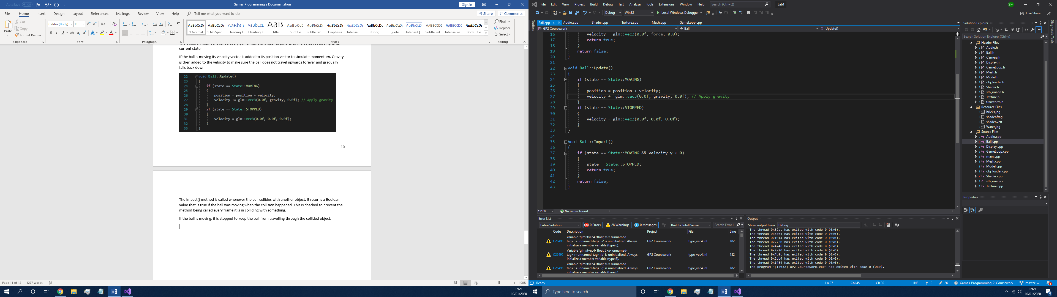

# Camera.h and transform.h

In addition to these classes, the main camera and transforms are handled in these header files.

The Camera header file contains methods for translating and rotating the main camera as well as returning a projection matrix for use in rendering.

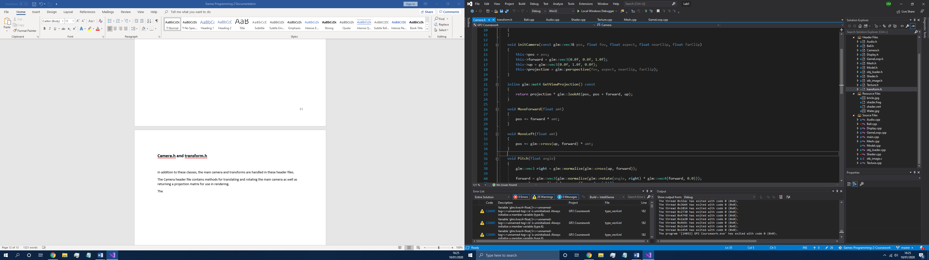

The transform header file contains the functionality for objects to have positions, rotations and scales as well as the ability to return the combined matrix for these.

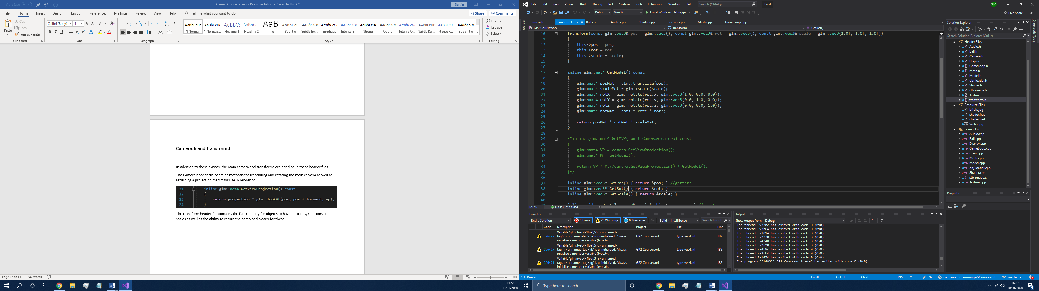

# GameLoop

The GameLoop class contains the main game loop and initialisation of the games systems. It also has the programs exit point.

Firstly, the games required classes are initialised in the constructor. These include pointers for the Display, Mesh, Texture, Shader, Audio and Ball classes. It also sets up the game state to GameState::PLAY as well as initialising the game counter to 0.

The Run() method starts the game which calls the InitSystems() method before beginning the main game loop, RunGameLoop();

The InitSystems method initialises the display and loads in all the required meshes, textures, shaders and audio files. The main camera is also set up here.

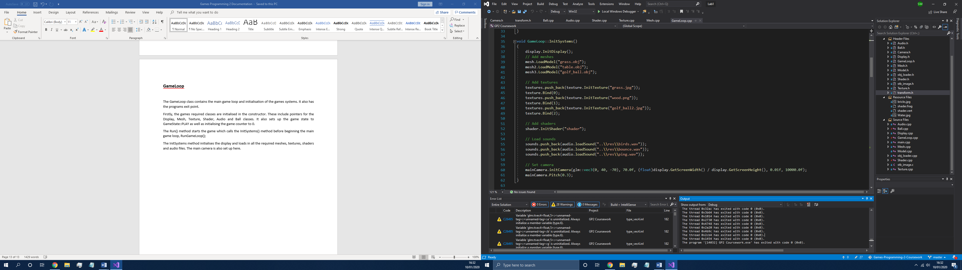

The RunGameLoop() method starts by playing the background music before continously looping through the several methods that control the game while the game state is set to PLAY. The order of these methods is to first process the players keyboard inputs, then update the physics before the collision detecting phase and finally drawing the game to the screen.

The ProcessInputs() method detects keystrokes using the SDL_Event class. It also sets the GameState to EXIT when SDL is quited.

The Update() method sets the positions of all the meshes and applies physics when required as well as incrementing the game counter. It also calls the Update() method on the Ball class.

The CollisionDetection() method checks for collisions in the game and calls the methods that handle any subsequent behaviour required.

Finally, the Draw() method is called which clears the display and draws all of the meshes by binding the shader and updating their transfrom in relation to the camera. The resultant mesh is then rendered with the desired texture.

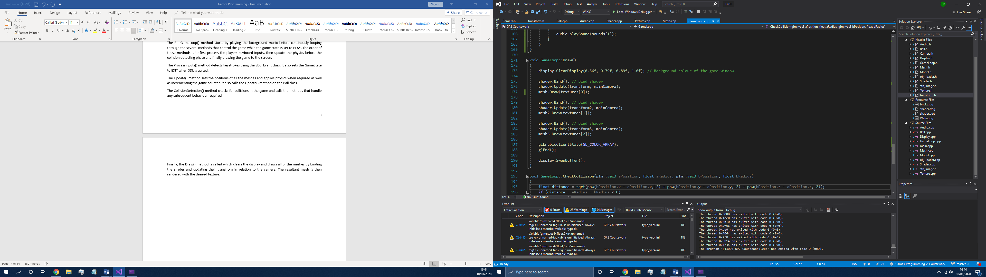

The display buffers are then swapped before starting the next iteration of the game loop.

The collsion detection makes use of the CheckCollision(…) method and returns true if a collision would be made.

